**Question 2**

SUMMARY REPORT FOR MY MODEL, THE SIMULATION OUTCOMES AND POLICY IMPLICATIONS

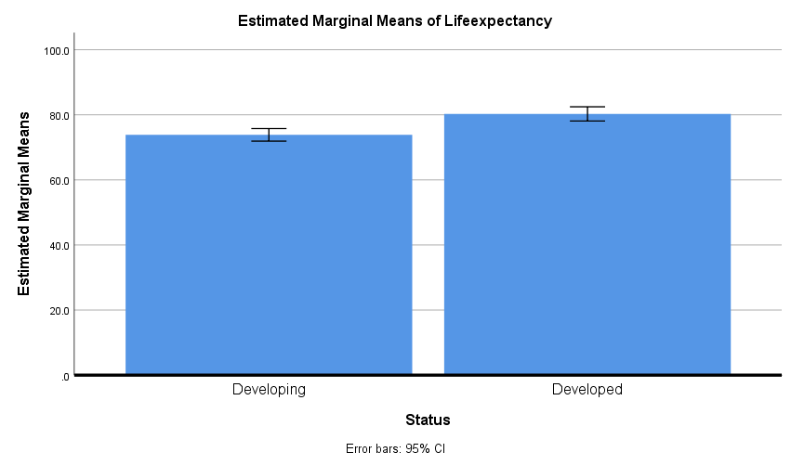

From the finding in the multivariate model that I created which uses multi variate multiple linear regressions on multiple variables to model a regression model for my outputs, it is observed that:

Life expectancy is generally higher in developed countries than it is in less developed countries as shown in the output plot above

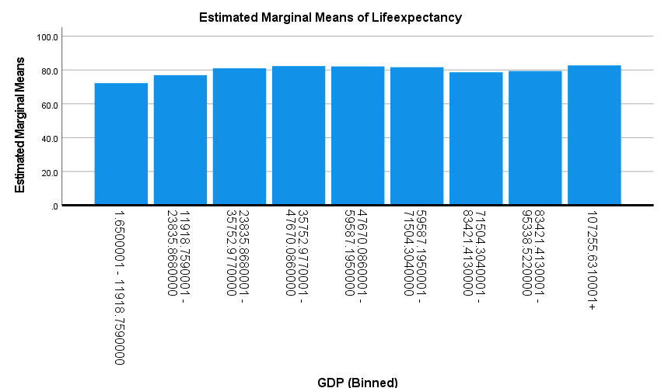

Life expectancy is seen to increase generally in countries with a higher GDP

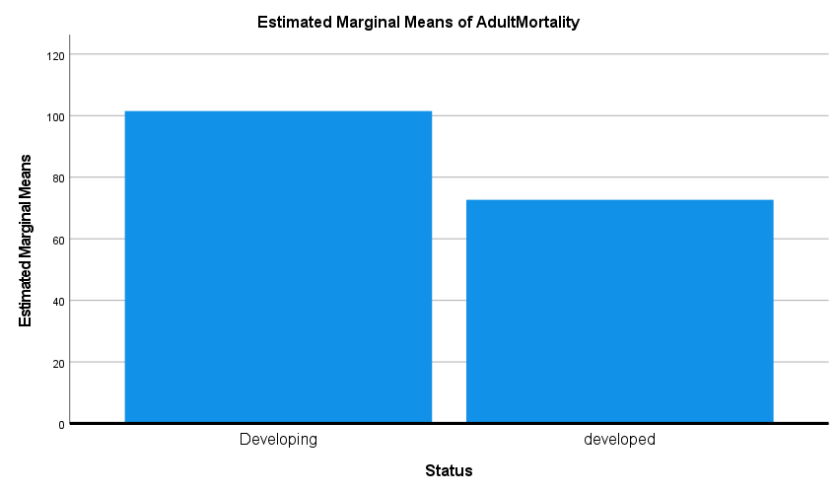

|  |  |  |
| --- | --- | --- |
|  | Life Expectancy | |
| Country | **Actual Value** | **Predicted Value** |
| Afghanistan | 65 | 66.89 |
| Albania | 73 | 66.89 |
| Argentina | 75.4 | 73.35 |

Based on the above excerpt from the model output, the model is seen to make predictions that are in a reasonable error bound to the actual values.